Contents
1. Introduction 2
2. Literature Review 3
Comprehensive Classifier Comparison via CRISP-DM (Chian et al., 2024) 3
Bayesian Predictive Modeling for Financial Uncertainty (Tanvir et al., 2024) 3
Solutions to the Class Imbalance Problem (Verma, 2019) 4
Machine Learning in the Indian Banking Context (Keerthana et al., 2024) 4
Foundational CRISP-DM and Sensitivity Analysis (Moro et al., 2011) 5
3. Methodology 5
3.1 Dataset Description 5
3.2 Data Preprocessing and Cleaning 6
3.3 Feature Transformation and Data Preparation 6
3.4 Exploratory Data Analysis 7
3.4.1 Correlation Analysis with Target Variable 8
3.5 Model Development 9
3.6 Model Evaluation 9
4. Results: 10
4.1 Logistic Regression Results 10
4.2 Decision Tree Results 11
4.3 Random Forest Results 11
4.4 Model Comparison and Discussion 12
5. Discussion 13
6. Conclusion 15
References 18

1. Introduction
Marketing campaigns have been an important aspect in the present financial institutions to attract customers and maximize the revenue. Direct marketing techniques that are commonly used by banks to market financial products include savings account, loans, and term deposits are phone calls, emails, or online advertisements. Nevertheless, such campaigns may be expensive and time consuming when it comes to reaching a big number of customers without knowing who is most likely to be positive in response. This leads to the fact that banks are becoming more and more dependent on data analytics and machine learning to enhance the efficiency of their marketing strategies.
Predictive modelling enables financial institutions to understand customer information in the past and trends that will reveal whether a customer is likely to subscribe to a financial product. Machine learning algorithms make organisations better able to target the potential customers, lower marketing expenses, and increase the conversion rates. This method is a sub-subfield of the broader field of predictive analytics and data-driven decision making which has emerged as a significant area of application in data science and financial technology.
A widely researched set of data on the issue is the UCI Bank Marketing set, which includes the data obtained in the direct marketing campaigns by a Portuguese banking organization. The data will contain demographic details of customers, financial details and past marketing communications. These variables offer important information on customer behaviour and enable machine learning models to develop trends that are related to effective marketing performance.
A number of machine learning methods have been used in the past studies to forecast term deposit subscriptions, such as the Logistic Regression, Decision Trees, Random Forest, and Support Vector Machines. Nevertheless, predictive performance of these models may be influenced by data preprocessing methods, feature selection and model configuration. As such, the systematic study and comparison of various algorithms should be done to identify the best model to use in this classification issue.
This paper will use and compare several trained machine learning models to determine whether a customer will take out a term deposit using the UCI Bank Marketing data. The study is aimed at identifying the algorithm that can give the most accurate and reliable predictions in the bank marketing applications through the analysis of the performance of various models and evaluation metrics. The results can be used to enhance the data-driven marketing in the banking industry and prove that the machine learning can be applied to facilitate more efficient financial decisions.
The question of the research of this study is:
Which can best predict a customer to subscribe to a bank term deposit based on the UCI Bank Marketing data set and which model has the highest predictive performance, according to evaluation measures of accuracy, precision, recall, and F1-score, on supervised machine learning models of Logistic Regression, Random Forest, and Decision Tree?

2. Literature Review
This literature review gives more technical information of the methodologies, exact findings of how the five leading research papers have conducted their comparative findings of predicting bank term deposit subscriptions.

Comprehensive Classifier Comparison via CRISP-DM (Chian et al., 2024)
- This paper deploys the CRISP-DM approach to oversee the entire data mining process, including business insight and model testing. The researchers used a Portuguese dataset (11,162 instances) to conduct rigorous data preparation, which involved the removal of outliers using Z-score tool, which narrowed down the dataset to 10,098 examples.
- Feature Engineering: The researchers reduced the number of input variables (16) to 8 important predictors (age, balance, day, campaign, pdays, housing_bool, contact_unknown, and poutcome_success) using a tree-based feature selection method (Random Forest).
- Model Performance: The study compared six algorithms that were used with Python libraries such as Scikit-learn and NumPy. The Random Forest (RF) model came out as the champion with a score of 73 percent and 0.73 ROC AUC. It was observed that RF was superior in locating pertinent data points as shown by a non-subscriber recall of 0.81. The researchers found moderate performance to be a weakness, and to increase accuracy to the next level (which is 73) hyperparameter tuning is required.0.81 for non-subscribers. The researchers identified moderate performance as a limitation, suggesting that hyperparameter tuning is necessary to maximize accuracy beyond the current 73%.

Bayesian Predictive Modeling for Financial Uncertainty (Tanvir et al., 2024)
- Tanvir et al. claim that classical models of frequentists offer only point estimates which do not capture inherent uncertainty of financial data. They rather use Bayesian Logit and Probit regression to utilize prior expert information using weakly informative normal priors.
- Methodology: This study made use of Markov Chain Monte Carlo (MCMC) simulations to compute posterior distributions. The balanced subset of 10,000 records was developed to allow a sensible comparison through oversampling to achieve 1:1 ratio of positive and negative responses.
- Comparative Results: As a Comparative Results, the study revealed the Logit model significantly outperformed the Probit model that had a much higher expected log pointwise predictive density (elpd_diff of 0.0 vs. -1860.9). The most crucial predictors were marital status, education, and method of contact..

Solutions to the Class Imbalance Problem (Verma, 2019)
Specifically, the study is devoted to the issue of the imbalance between the classes, where the minority yes class (5,289 instances) is dominated by the no class (39,922 instances) in the Bank Marketing Dataset, resulting in biased predictions.
Technical Implementation: With the WEKA machine learning tool, Verma used the following filters in the preprocess section: SpreadSubsample to under-sample, Resample to over-sample, and a certain SMOTE filter to balance the classes artificially to approximately 39,900 instances each.
Findings: The experiment compared Decision Tree (C 4.5), Naive Bayes, Multilayer Neural Networks and Random Forest. The findings indicated that the combination of Random Forest and SMOTE had the greatest precision (0.935) and AUCPR (0.989) of the minority class. It is worth noting that although under-sampling evened the distribution, important characteristics of data were lost.

Machine Learning in the Indian Banking Context (Keerthana et al., 2024)
This paper looks at the use of ML in India, which is a market that is becoming more and more digitalized with growing disposable incomes. To navigate this heterogeneous consumer base, the researchers used Stochastic Gradient Descent (SGD), k-nearest neighbor (KNN), and Random Forest.
Statistical Insights: Univariate analysis showed that income distribution is skewed to the right, which mirrors the actual disparities in the world, whereas education levels (Master, Bachelor, etc.) played a significant role in defining socio-economic features. The multivariate correlation analysis revealed that Age and Income are positively correlated with moderate levels (0.35), and the two factors, as well as past marketing interactions, positively affected subscription rates.
Top Models: Random Forest was the best model (with the highest accuracy of 90 percent, precision of 0.88 and F1-score of 0.87), which demonstrated a strong ability to capture the non-linear relationship of the Indian market.

Foundational CRISP-DM and Sensitivity Analysis (Moro et al., 2011)
This initial research has determined the applicability of Business Intelligence (BI) in facilitated marketing, in particular, a Portuguese bank that uses telephone-based marketing campaigns.
Iterative Refinement: The researchers narrowed the number of features in an iterative process of 59 client attributes (initial features) to 29 across three CRISP-DM iterations. They resorted to the rminer library in R to make things easier when it comes to complex classification.
Key Findings: Support Vector Machine (SVM) model using a Gaussian kernel was found to be the most effective with an AUC of above 0.9. Sensitivity analysis showed that the most relevant input was the Call Duration, i.e. longer calls were strongly associated with success. Also, the researchers observed a time trend: they were more likely to be successful during the final month of every trimester (March, June, September, and December).

3. Methodology
This paper follows a systematic data science approach to determine whether machine learning models would give an accurate forecast of the probability of a customer subscribing to a bank term deposit based on the Bank Marketing data available in the UCI Machine Learning Repository. The methodology process involves a number of steps such as data collection, data pre-processing, exploratory data analysis, feature transformation, model building, and performance assessment. These steps aid in the fact that the dataset is ready to be modelled and that the predictive success of the used algorithms will be assessed systematically.

3.1 Dataset Description
The data employed in this paper was retrieved in the UCI Machine Learning Repository and is based on a Portuguese bank. The data was gathered at the time of direct marketing campaigns, which were carried out in the period between May 2008 and November 2010. These were campaigns that included making of phone calls to the customers to market bank term deposits products.
The customer demographic, financial status and historical interactions with marketing campaigns are included in the dataset. The variables contained in the dataset were age, job, marital status, level of education, account balance, number of campaign contacts, and length of the last marketing call. In the dataset, the target variable is the variable y, which is a yes or no answer on whether or not the customer subscribed to a term deposit after the marketing interaction. This variable is a binary outcome in which 1 means a successful subscription and 0 does not mean subscription..

3.2 Data Preprocessing and Cleaning
The dataset was thoroughly inspected and preprocessed prior to implementing machine learning algorithms to make sure that the data is of good quality and consistency. First, the dataset structure was checked to determine the number of records, the types of variables and the possible inconsistencies. Checking of duplicate observations was done and eliminated as required to eliminate bias during the training process.
In spite of the fact that the dataset did not include the traditional missing values, some of the categorical attributes contained the label unknown that denotes missing or unspecified information. The unknown values were substituted with the most common category in the respective variable instead of dropping these observations. This method enabled the research to have as many records as possible and still have consistency in the dataset.
The target variable initially included the categorical values of yes and no. In order to make the data compatible with machine learning algorithms, these values were converted into a binary numerical representation. Yes was coded as 1, and no as 0, which means that the customer subscribed to the term deposit, and no subscription outcome was occurred.

3.3 Feature Transformation and Data Preparation
Since the dataset consists of categorical and numerical variables, prior to training the models a number of transformations were to be performed. One-hot encoding was used to convert categorical attributes (job, marital status, education, housing loan status, and past campaign outcomes). The method transforms categorical variables to binary indicator variables, which is why machine learning models can be trained on categorical data without the introduction of ordinal relationships between categories.
Numerical variables such as age, account balance, duration of campaign, number of people contacted during the campaign, and the number of people contacted before were normalised by feature scaling procedures. Standardisation will make sure that all the numerical features are on the same scale where the variables with greater numerical scale cannot overpower the learning process. Scaling of features leads to a better stability and convergence of machine learning algorithms.
After preprocessing and transformation, the data set was separated into a training dataset and testing dataset. The training dataset had around 80 percent of the observations whereas the rest 20 percent was set aside to be tested. Stratified sampling was used during the split in order to maintain the same distribution of the target variable in both datasets. This will make sure that the models operate on data which represents the real distribution of the classes.

3.4 Exploratory Data Analysis
Exploratory Data Analysis (EDA) was done to gain a better insight into the nature and distribution of the data prior to development of models. Several visualisations were generated to analyse the behaviour of important variables such as age, account balance, and campaign call duration. The patterns of distribution of these numerical features were observed using histograms.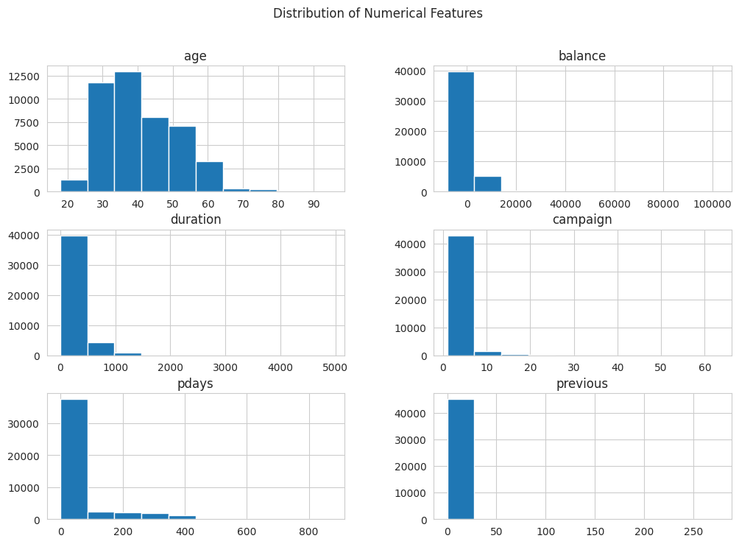
Moreover, the target variable distribution was also tested to determine the possible class imbalance between subscribing and non-subscribing customers. This distribution is significant to understand since an unbalanced set of data may affect the performance of models and bias the predictions to the majority.
In order to explore more relationships between variables, a correlation heatmap was produced based on the encoded dataset. The heatmap represents the magnitude and orientation of the relationships among numerical variables and the target one. The analysis assists in determining characteristics that can have a greater predictive power of customer subscription..

3.4.1 Correlation Analysis with Target Variable
To have more insights about the relation between the input features and target variable, correlation analysis was performed on the encoded dataset. The correlation heatmap was created to see the strength and direction of associations between variables and then a list of correlations in a ranked order within the target variable y (term deposit subscription).
The findings reveal that the duration is positively correlated with the target variable (0.394) and the longer the duration of the call, the more probable is the subscription rate. This is natural, because the longer the customer is involved in conversations, the more is the likelihood that they will positively respond to the marketing initiatives. Equally, the relationship between poutcome success (0.306) is strongly positive meaning that customers who answered campaigns positively in the past have a higher propensity to subscribe again.
A number of the temporal variables also exhibit moderate positive relationships, including month_mar (0.129), month_oct (0.128), and month_sep (0.123), indicating that the timing of campaigns is one of the factors that affect customer response behaviour. Also there are other variables like pdays (0.103) and previous (0.093) which suggests that the history of prior contact has a positive effect on subscription likelihood.
Conversely, there are others that are associated with the target variable negatively. As an example, poutcome -0.167 and housing yes (-0.139) have almost stronger negative relationships, which means that customers who have unknown previous outcomes or housing loans are less likely to subscribe. Likewise, campaign (-0.073) suggests that the more the number of contacts, the lower the likelihood of successful subscription, which could be because of customer fatigue.
Generally, the correlation analysis reveals that variables of customer interaction (duration and previous campaign results) play a key role in subscription behaviour than demographic characteristics. These findings can corroborate findings of the feature importance of the Random Forest model, in which duration and prior interaction-related variables also proved to be critical predictors.

3.5 Model Development
At this phase, various machine learning models with supervision will be constructed to solve the customer subscription to a term deposit classification problem. The three models to be used in this research are Logistic Regression, Decision Tree and Random Forest classifiers. The selection of these models is based on the fact that they are various learning models such as linear modelling, tree-based learning and ensemble methods.
A baseline model will be the Logistic Regression so that a reference level of performance can be set at which binary classification is going to be made. Decision Tree will be used to preserve potential nonlinear interactions between input features and the target variable and be interpretable. Random Forest will be used as an ensemble method to enhance predictive accuracy through combining several decision trees and decreasing the overfitting.
The models will be trained with the ready training dataset and produce predictions on the testing dataset. This step is aimed at performing the comparison of the overall performance of various algorithms on the same dataset and at determining which model is the most effective to predict customer subscription behaviour.

3.6 Model Evaluation
After the development of the models, the performance of every machine learning model will be measured with the help of various classification metrics. These are accuracy, precision, recall and F1-score that give a more holistic view of model performance. The measure of accuracy will be general correctness of the predictions, whereas precision and recall will be used to measure the effectiveness of the model in detecting positive subscription cases. Precision and recall will be balanced by using F1-score.
Besides the numerical measures, the confusion matrices will also be created to give a more detailed account of the prediction results, i.e., true positives, true negatives, false positives, and false negatives. This will assist in the realization of the strengths and weakness of each model.
Besides, a comparative analysis will be done to compare the performance of all models to each other. The results will be presented in the form of visualisations like model comparison plots. The analysis of feature importance, especially that of the Random Forest model, will also be provided to determine the most important variables in the prediction of customer subscription.
Results of this evaluation phase will be utilized in the next section to discuss the findings and identify which model is better to use in the given problem.

4. Results:
This part includes a critical analysis of the performance of the three applied machine learning models; Logistic Regression, Decision Tree, and Random Forest. The models were trained with the filtered data set and their results were measured with the traditional classification tools, such as accuracy, precision, recall, and F1-score. These metrics give a holistic perspective of how the model performs especially when there is a class imbalance, which has been proven to be a trait of the Bank Marketing dataset. Each model has been discussed and then the results given individually then the comparison made to see what model is the most effective in predicting customer subscription behaviour.

4.1 Logistic Regression Results
The Logistic Regression was used as a control trial model to measure the performance of a linear classification model on the data. The model obtained a score of 0.898, which showed that the model was able to classify the test instances at a rate of 89.8 percent. This would indicate good overall performance at first sight. Nevertheless, accuracy is not adequate to measure the classification models with imbalanced data since it may be deceptive in case one group prevails with other classes.
Further analysis of the performance indicators helps to see the key points. The model had a precision rate of 0.628 meaning that when the model forecasts a customer to subscribe to a term deposit, it is accurate approximately 62.8 times. This is an average capability of not making false positive predictions. The value of recall is however much less at 0.323, indicating that the model only correctly identifies 32.3 percentage of real subscription cases. This implies that many of the true positives are being missed.
The F1-score, which is the ratio of precision to recall, is 0.427, which shows that the model is not as effective at capturing positive cases. The low recall value implies that the Logistic Regression is skewed towards the majority (non-subscription) class, which is prevalent due to the imbalanced datasets. Consequently, the model is likely to categorize numerous real subscribers as non-subscribers.
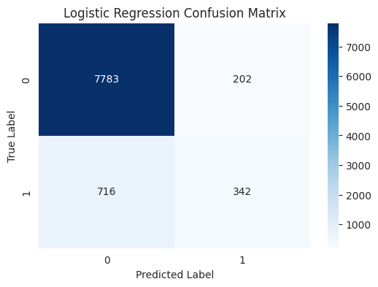This observation is also backed up by the confusion matrix which indicates that there are a large number of true negatives and a relatively small number of true positives. This imbalance shows the weakness of Logistic Regression in the situation. Although the model is good at determining non-subscribers, it may not be so effective when it comes to determining the potential customers who would probably become subscribers. This is a weakness that minimizes its usefulness in real-life marketing contexts where it is important to have the potential subscribers known.

4.2 Decision Tree Results
The Decision Tree model was adopted to model nonlinear associations amid input features and target variable. Decision Trees, in contrast to Logistic Regression, are able to fit complex interactions between variables and are therefore appropriate when dealing with mixed type features and nonlinear relationships.
The Decision Tree obtained an accuracy of 0.865 which is a little lower than that of Logistic Regression. The model however exhibits alternative behaviour when precision and recall are used to evaluate it. The value of precision of 0.426 shows that the model generates more false positives than Logistic Regression. Differently put, the model is only right under half the time when it predicts a subscription.
Conversely, the recall value of 0.452 is quite much greater than that of Logistic Regression. This means that the Decision Tree is more effective in identifying the real subscribers and it is able to capture the correct positive cases with a hit rate of around 45.2%. This recall improvement indicates that the model is sensitive to the minority class which is a significant advantage in this application.
The F1-score of 0.439 indicates a more equal trade-off between precision and recall than what is available with Logistic Regression. Although the Decision Tree loses some accuracy and precision, it trades off with better recall and is thus more effective at finding out which subscribers there may be.
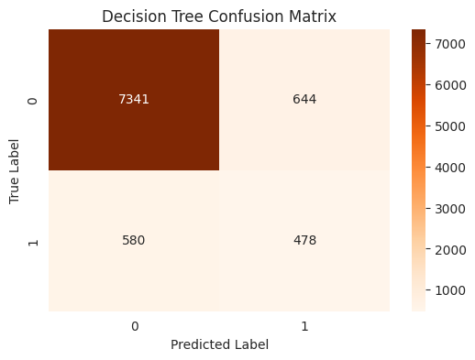The Decision Tree confusion matrix indicates that the number of true positives is higher than with the Logistic Regression, but false positives are also higher. It means that the model is more aggressive in predicting the positive category, and such a feature can be useful in marketing situations when predicting potential customers is more crucial than false positives.
Decision Trees are however subject to overfitting, especially when they are not regularised. This could be the reason of the reduced general accuracy and precision. Regardless of this drawback, the model offers good understanding of interactions among features and enhances the identification of the minority class.

4.3 Random Forest Results
Random Forest model was applied as an ensemble model of learning to enhance predictive performance and overcome the shortcomings of single decision trees. Random Forest limits the problem of overfitting and improves generalisation by aggregating the predictions of several decision trees.
The model was the most accurate of all models with 0.907 which is better overall classification performance. This implies that the Random Forest model can make the right classification of a higher percentage of observations than both the Logistic Regression and Decision Tree model.
The highest score of the three models based on precision is 0.673, which is the value of the Random Forest. This means that the model can predict a subscription in a way that is right about 67.3 percent of the time. The above enhancement reveals that Random Forest is more faithful in detecting true positive cases and reducing false positives.
The recall value is higher than that of Logistic Regression but lower to a small extent than that of the Decision Tree. It indicates that the Random Forest is, in a way, less aggressive compared to the Decision Tree in detecting all potential subscribers, although it is a good algorithm to detect positive cases. This trade-off is, however, compensated by an important gain in accuracy.
The F1-score of 0.496 is the greatest among all the models and this implies that the model is the most balanced in terms of precision and recall. This illustrates that Random Forest attains better trade-off between the right identification of subscribers and the wrong identification of subscribers.
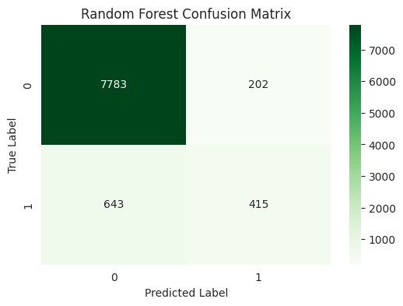
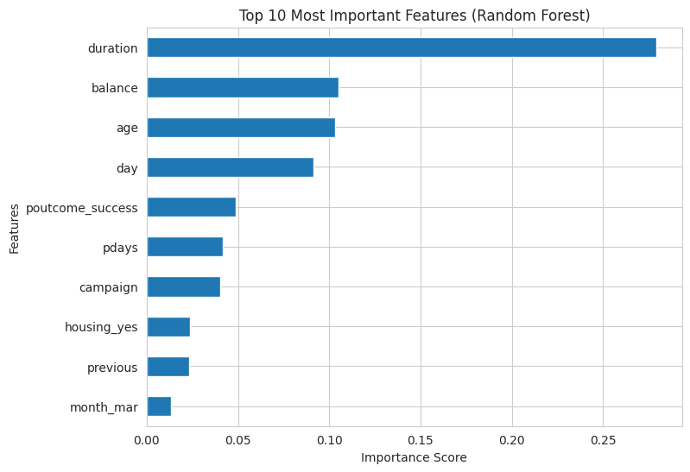
The importance of features analysis further substantiates these findings by indicating that the variables of duration, balance, and prior campaign outcomes have the biggest influence on predictions. This correlates with the correlation analysis above, which supports the significance of interaction-based features in the determination of customer behaviour..

4.4 Model Comparison and Discussion
An overall comparison of the three models brings out distinct performance and behavioural differences. Although Logistic Regression was relatively accurate, the recall was low, which means that it is highly biased towards the majority class. This renders it not applicable in situations where determining the potential subscribers is of utmost importance.
The Decision Tree model has increased the recall rates and is therefore more useful in identifying positive cases. This was however at the expense of a lower rate of precision and accuracy meaning that it will have more false positives. Although such behaviour is tolerable in some situations, it decreases the overall credibility of the model.
Random Forest was found to be more accurate, precise, and F1-score than both models, which proves that this model could be able to balance the predictive performance. Even though its recall is a little lower than that of the Decision Tree, it offers a superior overall trade-off between true positives and false positives reduction.
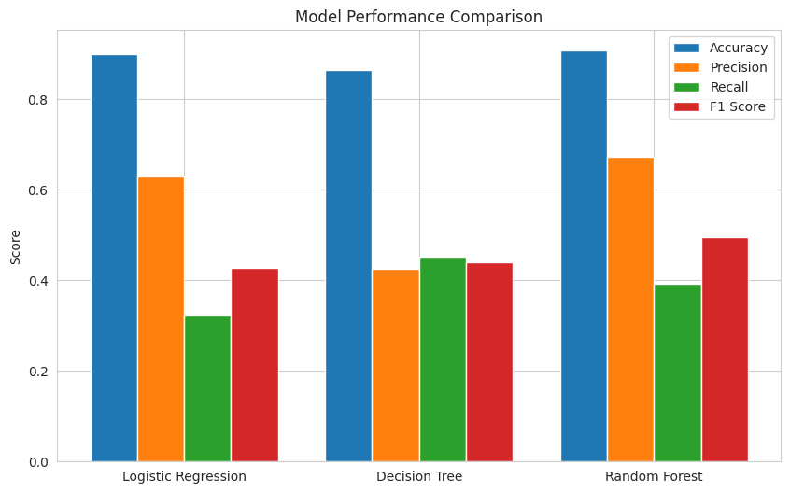The results of the comparison demonstrate clearly that the most appropriate model that should be used in this classification problem is the Random Forest. Its ensemble character enables it to be able to capture intricate relationships in the data without compromising its strength and generalisation. Also, the model can shed some valuable light on the importance of features that can be applied in marketing strategies.
On the whole, the findings indicate that simpler models like the Logistic Regression can be used as an effective baseline but more complicated models like the Random Forest can be used to achieve better results on complex and imbalanced data. These results indicate that ensemble methods are especially useful in the case of financial marketing where predictive accuracy and reliability are critical

5. Discussion
This part is a detailed interpretation of the study findings with regard to the research question, the literature reviewed and the research methodology used. The main aim of the study was to test the effectiveness of the supervised machine learning models, i.e. Logistic Regression, Decision Tree and random Forest, in predicting the customer subscription to a bank term deposit using UCI Bank Marketing data and the evaluation metrics to be used include accuracy, precision, recall, and F1-score.
Findings of this research suggest that the three models could do the classification task but they did not perform well with respect to the criteria used to evaluate them. The accuracy of the Logistic Regression was relatively high and this is an indicator of good performance. Nevertheless, the model had evident drawbacks when tested in terms of recall and F1-score in the recognition of real subscription cases. This puts into focus one of the problems with classification tasks using unbalanced datasets where accuracy is in itself a deceptive measure. In the context of this project, this outcome indicates that although the Logistic Regression offers a good starting point, it cannot be used to properly answer the research question because it does not satisfactorily represent the minority group.
The Decision Tree model showed another performance profile. Despite having lower overall accuracy than the Logistic Regression, it had a higher recall, meaning it was more useful in determining the real subscribers. This is in line with the goal of marketing prediction, in which it can be more significant to identify potential customers than to prevent false positives. Nevertheless, the Decision Tree also had low precision, that is, it made more false positive predictions. This trade-off indicates how the model has overfitting and aggressive predicting tendencies. With regard to the research question, Decision Tree partially enhances predictive performance but does not provide the balance that is necessary to make accurate decisions in practical situations.
Random Forest model gave the best balanced outputs having the highest accuracy, precision, and F1-score compared to any other model. Its recall was marginally lower than that of the Decision Tree, but it still performed better than Logistic Regression and had a high level of accuracy in balancing between the true positives and the false predictions. This is a direct response to the research question since Random Forest proved to have the best overall predictive performance in terms of the chosen evaluation metrics. The ensemble characteristics of the model enable it to depict intricate patterns in the data whilst minimizing overfitting, which makes the model especially appropriate to this kind of classification issue.
The results are in line with the literature analyzed above. Several researches indicated that the Random Forest is among the best frameworks to use when performing the task of predicting bank marketing. To illustrate, studies based on CRISP-DM models and ensemble techniques also found that Random Forest was a highly performing model because it has the capacity to address nonlinear associations and imbalanced data. On the same note, research into the problem of class imbalance revealed that ensemble algorithms, especially in combination with methods like SMOTE, are much more effective in predictive performance. These findings are supported by the results of this study, which makes Random Forest reliable in this field.
Besides, the significance of interaction-based characteristics revealed in this research, including the duration of a call and past campaign results, also confirms conclusions made in literature. Previous studies underlined that the variables of customer engagement are some of the most powerful predictors of subscription behaviour. This is seen in both the results of correlation analysis and feature importance that were acquired in the present research where the duration and past campaign success were identified to have the greatest impact on the target variable. This agreement between the present findings and the prior studies enhances validity of the findings.
In terms of methodology, the systematic approach used in the research study helped in the delivery of credible findings. Data preprocessing methods like the treatment of unknown values, categorical variables encoding, and numerical feature scaling made sure that the dataset was in a machine learning model format. Stratified train-test splitting was used to ensure the distribution of classes, which is especially significant in skewed data. Also, the results of the several evaluation metrics offered a more in-depth evaluation of the model performance instead of using just the accuracy.
The fact that exploratory data analysis and correlation analysis were included as well was also important to comprehend the dataset. The determination of key variables that affect subscription behaviour made some useful insights that helped in interpreting the model. This methodological approach is consistent with the general data science practice and represents the significance of using both the statistical analysis and machine learning techniques.
There are however limitations to this project in as much as it has these strengths. The article was based on one set of data of a bank in Portugal, and this could restrict the applicability of the findings to other areas or banking environments. Also, although several models have been compared, more sophisticated methods like hyperparameter optimization, cross-validation, and methods of handling class imbalance (e.g., SMOTE) were not applied widely. These approaches may be added to improve the performance of the model and achieve more robust results.
Furthermore, the analysis was based on general metrics of classification, and the cost-sensitive analysis was not taken into account. In practice, the costs of false positives and false negatives in banking might vary greatly, and future studies may take such factors into consideration to enhance the practical applicability. To illustrate, a wrong prediction of a non-subscriber being a subscriber will make the organization spend money on marketing that is not necessary, and a wrong decision against a potential subscriber will mean that the organization will miss out on the revenue opportunity.
To sum up, this research was able to fill the research question through the evidence that machine learning models are capable of accurately predicting customer subscription behaviour, and that the best model to apply in the context of this project is Random Forest. The results indicate the significance of choosing the right evaluation measures, imbalance in the classes, and the use of strong modelling methods. Moreover, the fact that the findings are aligned with the existing literature also supports the authenticity of the research and proves the importance of machine learning in enhancing evidence-based decision-making in the banking industry.

6. Conclusion
This paper was intended to examine how well machine learning models that are under supervision can forecast customer subscription to a bank term deposit using the UCI Bank Marketing data. The study aimed at comparing three widely applied classification models namely Logistic Regression, Decision Tree and Random Forest and comparing their performance in terms of significant evaluation measures such as accuracy, precision, recall, and F1-score. It was to establish what model gives the best reliable and effective predictions in the environment of direct marketing in the banking industry.
As the study results reveal, machine learning models can be successfully used to forecast customer behaviour in a financial marketing context. All models had their own advantages and disadvantages, which demonstrated the necessity to choose proper algorithms depending on the demands of the concrete problem. A baseline model was Logistic Regression that was fairly accurate but had a low recall. It means that although it is quite efficient in identifying the non-subscribers, it does not identify a large percentage of the real subscribers, which precludes its application in marketing contexts where it is important to identify the potential customers.
Decision Tree model had better recall indicating greater ability to detect actual cases of subscription. Nevertheless, the increase in precision and accuracy was at the expense of lower accuracy and accuracy, which implies that the model generates more false positive predictions. Although this might be agreeable in some situations, it decreases the accuracy of the model in real life situations where resource allocation is a factor of concern.
Random Forest had the highest overall performance when compared to the other two models. It attained the highest accuracy, precision and F1-score meaning that there was a high balance between being able to identify the subscribers and minimising the number of false predictions. Even though it had a slightly weaker recall than the Decision Tree, it had more balanced and healthy performance. The above findings indicate that ensemble-based algorithms, like the Random Forest, can be successfully applied to complex and skewed datasets, so they are suitable to real-world financial prediction problems.
The results of this research are in agreement with the existing literature, which also shows that Random Forest is a good performer in the bank marketing prediction problems. The significance of such characteristics as call duration and past campaign performance, determined by correlation analysis and feature importance analysis, also confirm conclusions made in the literature. These findings demonstrate the importance of the variables of customer interaction in the determination of subscription behaviour.
In practical terms, the findings suggest that machine learning models can be used by financial institutions to enhance the effectiveness and efficiency of their marketing campaigns. The identification of more likely to subscribe customers helps banks to optimise their targeting strategy, lower their marketing expenses and increase their overall campaign success rates. This is in line with the overall objective of data-driven decision-making within the contemporary financial systems.
Nevertheless, the research too has its flaws. The study has been based on one dataset of a Portuguese bank that can restrict the externalisation of the results. Also, more sophisticated methods, like hyperparameter optimization, cross-validation and addressing the imbalance between classes through techniques like SMOTE, were not thoroughly studied. Future studies would be able to overcome such limitations by including more sophisticated modelling methods and performance assessment in various datasets and settings.
Finally, this paper was able to address the research question by showing that machine learning models are able to accurately forecast customer subscription behaviour, with Random Forest being the most appropriate model in the context of this project. The findings underscore the significance of model selection, evaluation metrics and data characteristics in obtaining the reliable predictions. Moreover, the paper also outlines how machine learning can be utilized to achieve better and more efficient marketing practices within the banking industry.

References
- Abbas, S., 2015. Deposit subscribe prediction using data mining techniques based real marketing dataset. arXiv preprint arXiv:1503.04344.
- Chian, L.X., Khaw, K.W., Chew, X., Alnoor, A. and Ng, W.C., 2024. Bank direct marketing campaign success prediction. Applied Mathematics and Computational Intelligence (AMCI), 13(3), pp.95-114.
- Elsalamony, H.A., 2014. Bank direct marketing analysis of data mining techniques. International Journal of Computer Applications, 85(7).
- Fitriani, M.A. and Febrianto, D.C., 2021. Data mining for potential customer segmentation in the marketing bank dataset. JUITA: Jurnal Informatika, pp.25-32.
- Gerling, C. and Lessmann, S., 2024. Leveraging AI and NLP for bank marketing: A systematic review and gap analysis. arXiv preprint arXiv:2411.14463.
- Kok-Chin, K. and Keng-Hoong, N., 2016. Evaluation of cost sensitive learning for imbalanced bank direct marketing data. Indian Journal of Science and Technology, 9, p.42.
- Mancisidor, R.A., Kampffmeyer, M., Aas, K. and Jenssen, R., 2021. Learning latent representations of bank customers with the variational autoencoder. Expert Systems with Applications, 164, p.114020.
- Moro, S., Laureano, R. and Cortez, P., 2011, October. Using data mining for bank direct marketing: An application of the crisp-dm methodology. In Proceedings of the European Simulation and Modelling Conference-ESM (Vol. 2011).
- Tanvir, M.F., Hossain, M.M. and Jishan, M.A., 2024, December. Bayesian Regression for Predicting Subscription to Bank Term Deposits in Direct Marketing Campaigns. In 2024 International Conference on Decision Aid Sciences and Applications (DASA) (pp. 1-5). IEEE.
- Verma, A., 2019. Evaluation of classification algorithms with solutions to class imbalance problem on bank marketing dataset using WEKA. International Research Journal of Engineering and Technology, 5(13), pp.54-60.
- Zaki, A.M., Khodadadi, N., Hong Lim, W. and Towfek, S.K., 2024. Predictive Analytics and Machine Learning in Direct Marketing for Anticipating Bank Term Deposit Subscriptions. American Journal of Business & Operations Research, 11(1).

